## SQLyog Setup

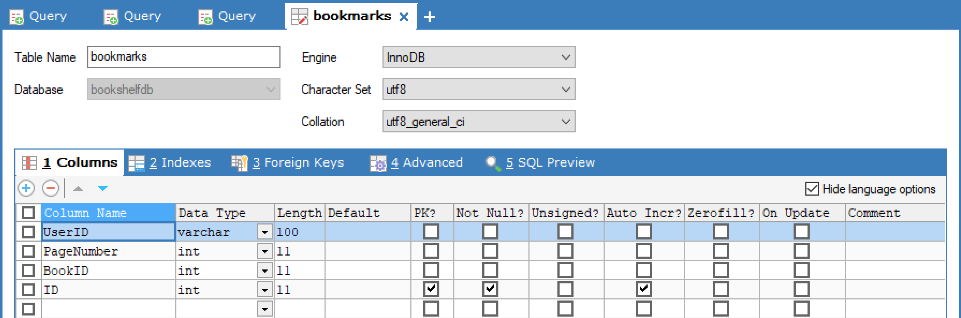**Bookmarks Database**

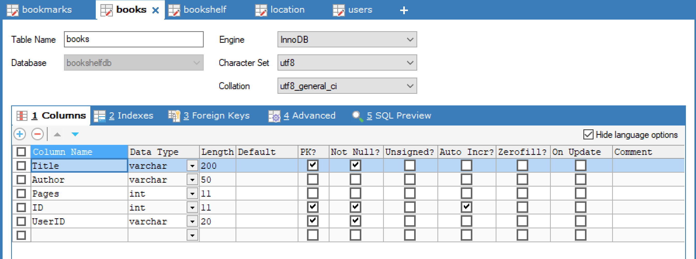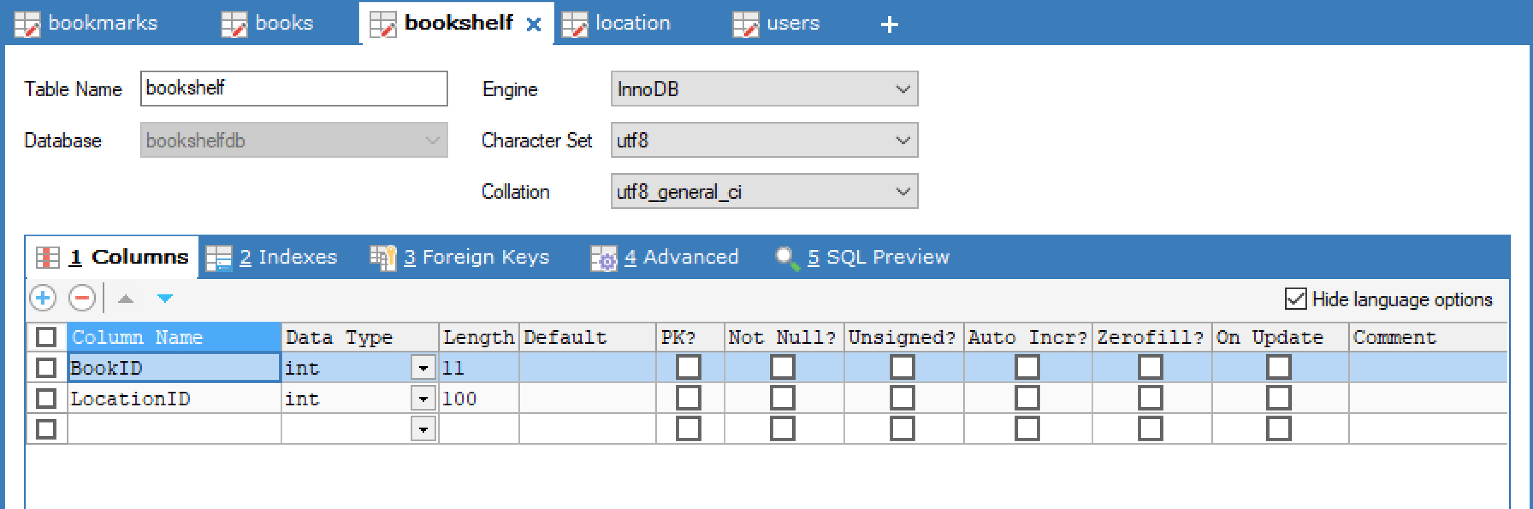

**Bookshelf Database**

**Books Database**

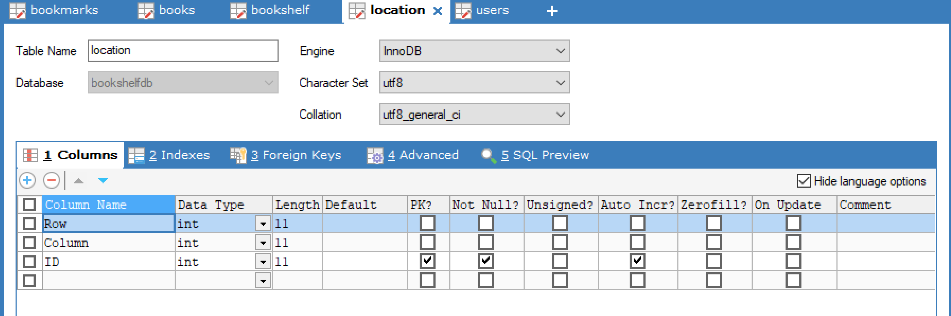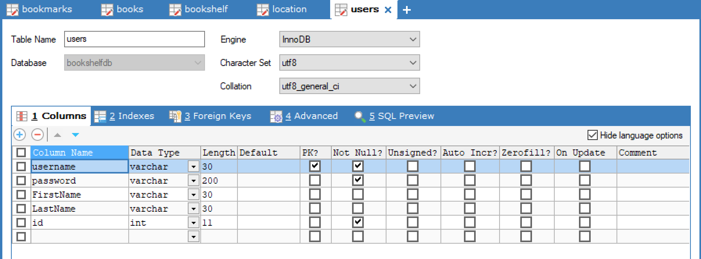

**Location Database**

**Users Database**